Project Planning Phase
Project Planning Template (Product Backlog, Sprint Planning, Stories, Story points)

Date | 30 June 2025
Team ID | LTVIP2026TMIDS24294
Project Name | BOOKNEST-WHERE STORIES NESTLE
Maximum Marks | 5 Marks

Product Backlog, Sprint Schedule, and Estimation (4 Marks)

Sprint | Functional  Requirement (Epic) | User Story  Number | User Story / Task | Story Points | Priority | Team  Members
Sprint-1 | Registration | USN-1 | As a user, I can register for the application by entering my email, password, and confirming my password. | 2 | High | Parasa Lavanya
Sprint-1 | Registration | USN-2 | As a user, I will receive confirmation email once I have registered for the application | 1 | High | Gogula Supriya
Sprint-2 | Registration | USN-3 | As a user, I can register for the application through Facebook | 2 | Low | Fayaz Khan
Sprint-1 | Registration | USN-4 | As a user, I can register for the application through Gmail | 2 | Medium | Gogula Supriya
Sprint-1 | Login | USN-5 | As a user, I can log into the application by entering email & password | 1 | High | Parasa Lavanya
Sprint-2 | Dashboard | USN-6 | As a user, I can view the dashboard with my recent orders and recommended books. | 3 | High | Fayaz Khan
Sprint-2 | Dashboard | USN-7 | As a seller, I can view the list of books I uploaded with edit/delete options. | 3 | Medium | Gogula Supriya
Sprint-2 | Dashboard | USN-8 | As an admin, I can see platform analytics including number of users and orders. | 5 | High | Parasa Lavanya

Project Tracker, Velocity & Burndown Chart: (4 Marks)
Sprint | Total Story Points | Duration | Sprint Start Date | Sprint End Date (Planned) | Story Points  Completed (as on  Planned End Date) | Sprint Release Date (Actual)
Sprint-1 | 20 | 6 Days | 18 May 2025 | 23 May 2025 | 20 | 23 May 2025
Sprint-2 | 20 | 6 Days | 24 May 2025 | 29 May 2025 | 20 | 29 May 2025
Sprint-3 | 20 | 6 Days | 30 May 2025 | 04 Jun 2025 | 20 | 04 Jun 2025
Sprint-4 | 20 | 6 Days | 05 Jun 2025 | 10 Jun 2025 | 20 | 10 Jun 2025
Sprint-5 | 20 | 6 Days | 11 Jun 2025 | 16 Jun 2025 | 20 | 16 Jun 2025
Sprint-6 | 20 | 6 Days | 17 Jun 2025 | 22 Jun 2025 | 20 | 22 Jun 2025
Sprint-7 | 20 | 6 Days | 23 Jun 2025 | 28 Jun 2025 | 20 | 28 Jun 2025
Sprint-8 | 20 | 2 Days | 29 Jun 2025 | 30 Jun 2025 | 20 | 30 Jun 2025

Velocity:
Imagine we have a 10-day sprint duration, and the velocity of the team is 20 (points per sprint). Let’s calculate the team’s average velocity (AV) per iteration unit (story points per day)

AV=620​≈3.33 story points/day

Burndown Chart:
A burn down chart is a graphical representation of work left to do versus time. It is often used in agile software development methodologies such as Scrum. However, burn down charts can be applied to any project containing measurable progress over time.

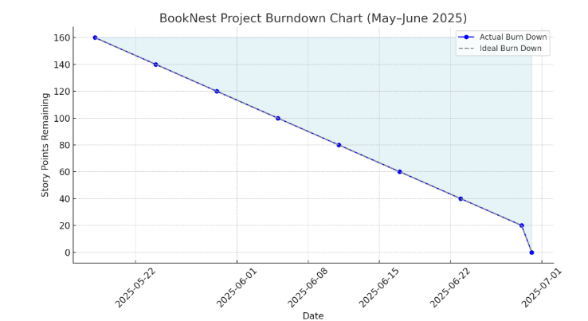

https://www.visua
l
-
paradigm.com/scrum/scru
m
-
burndow
n
-
chart
/

https://www.atlassian.com/agile/tutorials/burndow
n
-
chart
s

Reference:

t
https://www.atlassian.com/agile/projec
-
managemen
t

https://www.atlassian.com/agile/tutorials/ho
w
-
t
o
-
d
o
-
m
scru
-
wit
h
-
jir
a
-
softwar
e

https://www.atlassian.com/agile/tutorials/epic
s

https://www.atlassian.com/agile/tutorials/sprint
s

https://www.atlassian.com/agile/projec
t
-
management/estimatio
n

https://www.atlassian.com/agile/tutorials/burndow
n
-
chart
s

